Dear students,

The Maths preparatory work is all available by clicking the link below:

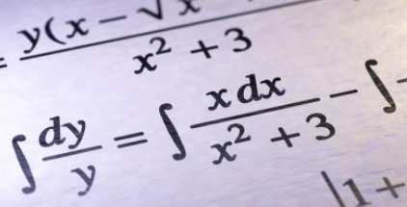
https://sites.google.com/bristolcathedralschools.org/bccs-y11maths-nextsteps/home

You will be directed to our website. For Maths in particular, the work you do between now and the beginning of your A level is crucial. Often, it can determine your success as knowing the ‘basics’ is the foundation you need to be able to access the next stage.

Good luck,
The Maths Department

