BCCS

Physics Induction
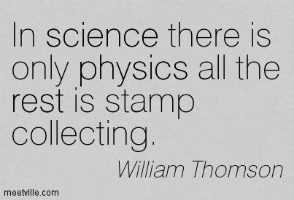

Welcome to AS Physics!

This course is intended to provide, through well designed studies of theoretical and practical Physics, a worthwhile educational experience for all candidates, whether or not they go on to study Physics at a higher level. The Physics teachers at BCCS are passionate about their subject and enjoy sharing their enthusiasm with students.

The government has recently changed the format of A-levels so that AS-levels are a stand-alone qualification that does not contribute to the full A-level qualification. At BCCS you will be entered for the 2-year A-Level qualification, and will be assessed internally at the end of year 12 to provide you with feedback about how you are progressing.
The exams at the end of year 13 will therefore assess you on all the Physics content covered in both year 12 and 13.

Alongside the content, you will be undertaking 6 Required Practicals each year. These will allow you to develop your understanding of practical techniques and data analysis – a skillset that universities find highly desirable.
AQA Physics at a Glance

The first year of study will cover topics 1-5, and some of topic 6. The rest of the content will be learned the following year.
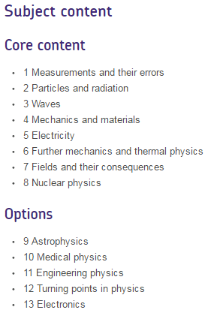

For the optional module, we have taught the ‘Astrophysics’ modules in recent years. It is likely that we will teach the Astrophysics module again in your Y13. We have chosen this as it is an exciting area of current research and demonstrates how our ideas about the universe are changing today, driven by practical research, including trying to solve the puzzles of Dark Matter and Dark Energy.
Assessment
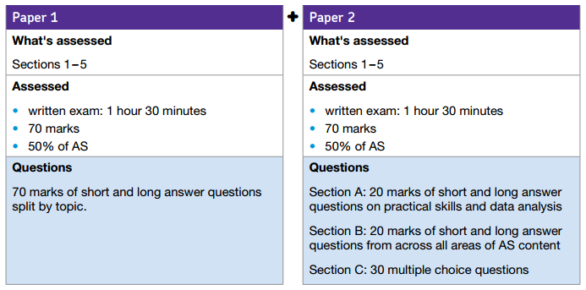
Towards the end of year 12 you will sit an internal assessment on the content covered up to that point:
In year 13 you will sit the external AQA Physics (7408) exams. The papers will contain content from both the first and second years of the course. They will be divided up as follows:
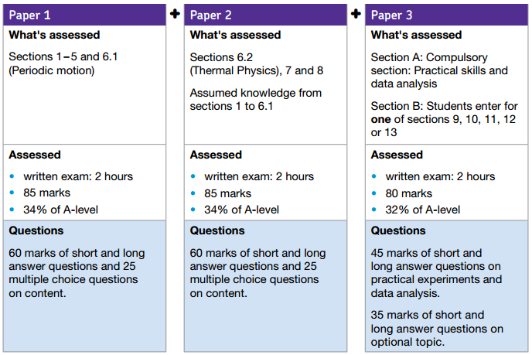

Required Practicals
As part of the Physics course there are 12 Required Practicals that you must complete throughout your course; 6 in each year.
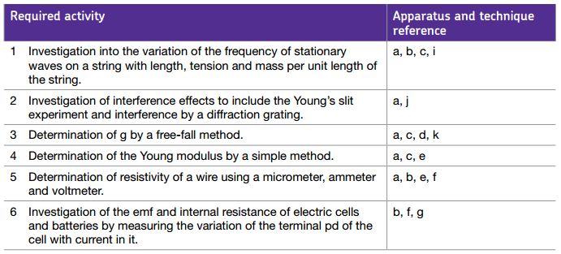
The assessed practicals you will complete in year 12 are:
Over the two years, they will develop your skills in the use of the following apparatus and techniques:
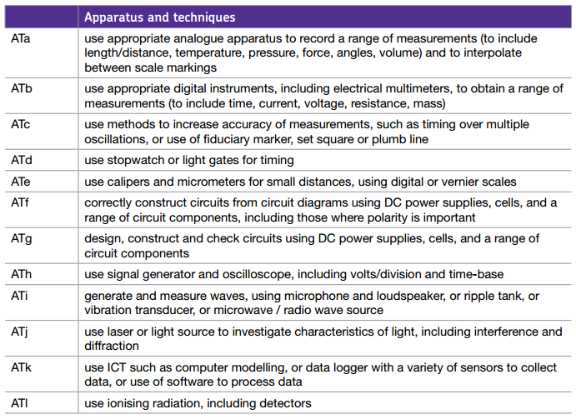

Complete these tasks to prepare you for the AS Level Content:
Topic 1 - Electricity
- Write definitions for these key terms:
- Current
- Voltage
- Power
- Ammeter
- Voltmeter
- Resistance

- Draw characteristic graphs for a diode, filament lamp, thermistor and LDR. Explain the shape of each.

- How does current behave in a) a series circuit? b) a parallel circuit?

- Find out what resistivity is and what equation is used to calculate it?

- What is a superconductor? What are they used for?
Topic 2 – Particle Physics
- Find out what Plum-pudding model of the atom was, who came up with it, and what experimental results led that person to propose it.

- Rutherford later proposed the nuclear model of the atom following some experimental results from Geiger and Marsden’s experiment with gold leaf. Draw a picture of his model and find out five facts about the experiment.
- Complete the table below
Constituent of the atom | Symbol | Relative Charge | Charge (C) | Mass
Proton
Neutron
Electron

- What are the four fundamental forces of nature?
- What is a quark?
Complete these tasks to prepare you for the AS Level mathematical skills requirements:

Prefixes

In Physics we have to deal with quantities from the very large to the very small. A prefix is something that goes in front of a unit and acts as a multiplier. This sheet will give you practice at converting figures between prefixes.

Symbol | Name | What it means |  | How to convert
P | peta | 10¹⁵ | 1000000000000000 |  | ↓ x1000
T | tera | 10¹² | 1000000000000 | ↑ ÷ 1000 | ↓ x1000
G | giga | 10⁹ | 1000000000 | ↑ ÷ 1000 | ↓ x1000
M | mega | 10⁶ | 1000000 | ↑ ÷ 1000 | ↓ x1000
k | kilo | 10³ | 1000 | ↑ ÷ 1000 | ↓ x1000
 |  |  | 1 | ↑ ÷ 1000 | ↓ x1000
m | milli | 10⁻³ | 0.001 | ↑ ÷ 1000 | ↓ x1000
μ | micro | 10⁻⁶ | 0.000001 | ↑ ÷ 1000 | ↓ x1000
n | nano | 10⁻⁹ | 0.000000001 | ↑ ÷ 1000 | ↓ x1000
p | pico | 10⁻¹² | 0.000000000001 | ↑ ÷ 1000 | ↓ x1000
f | femto | 10⁻¹⁵ | 0.000000000000001 | ↑ ÷ 1000

Convert the figures into the prefixes required.

s | ms | μs | ns | ps
134.6
96.21
0.773

m | km | mm | Mm | Gm
12873
0.295
57.23

kg | Mg | mg | g | Gg
94.76
0.000765
823.46

A | mA | μA | nA | kA
0.000000678
3.56
0.00092

Significant Figures

Calculate the mean of the values below then write the answer to the appropriate number of significant figures

Value 1 | Value 2 | Value 3 | Mean Value | Mean to correct sig figs
1 | 1 | 2
435 | 299 | 4130
500 | 600 | 900
3.038 | 4.925 | 3.6
720 | 498 | 168
1655 | 2996 | 140
0.230 | 925.8 | 56300
26017 | 19.1 | 0.186
2238 | 80.1324 | 1.427
9160.97 | 2011 | 34
62.99 | 127.416 | 326.19
155.56 | 11.97 | 1.4

Rearranging and Deriving Equations

Rearrange 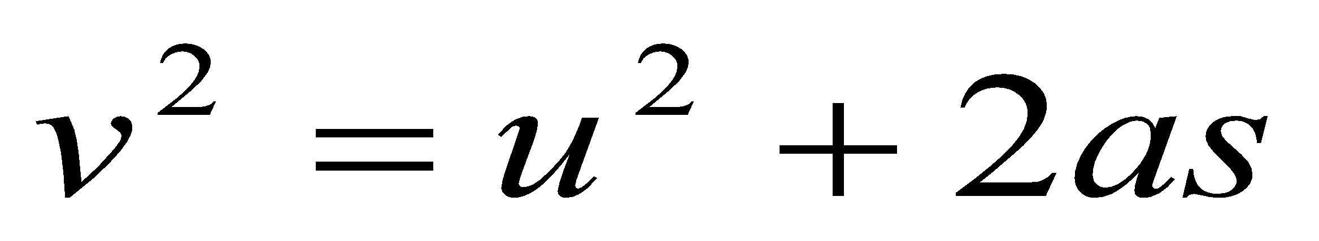 to make a the subject
Substitute this into 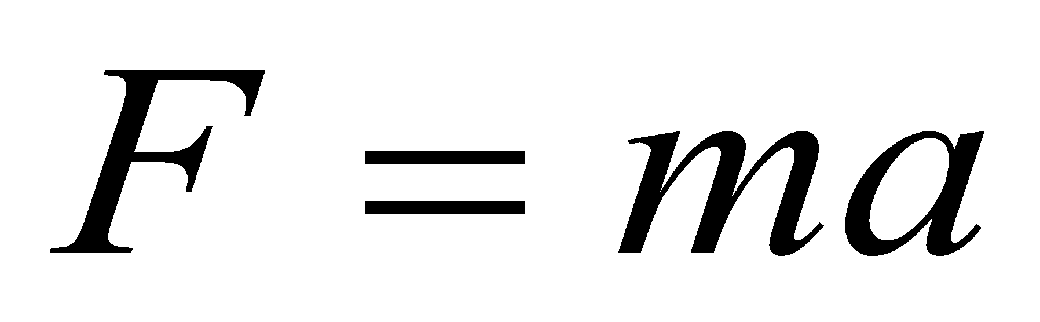
Substitute this into the equation 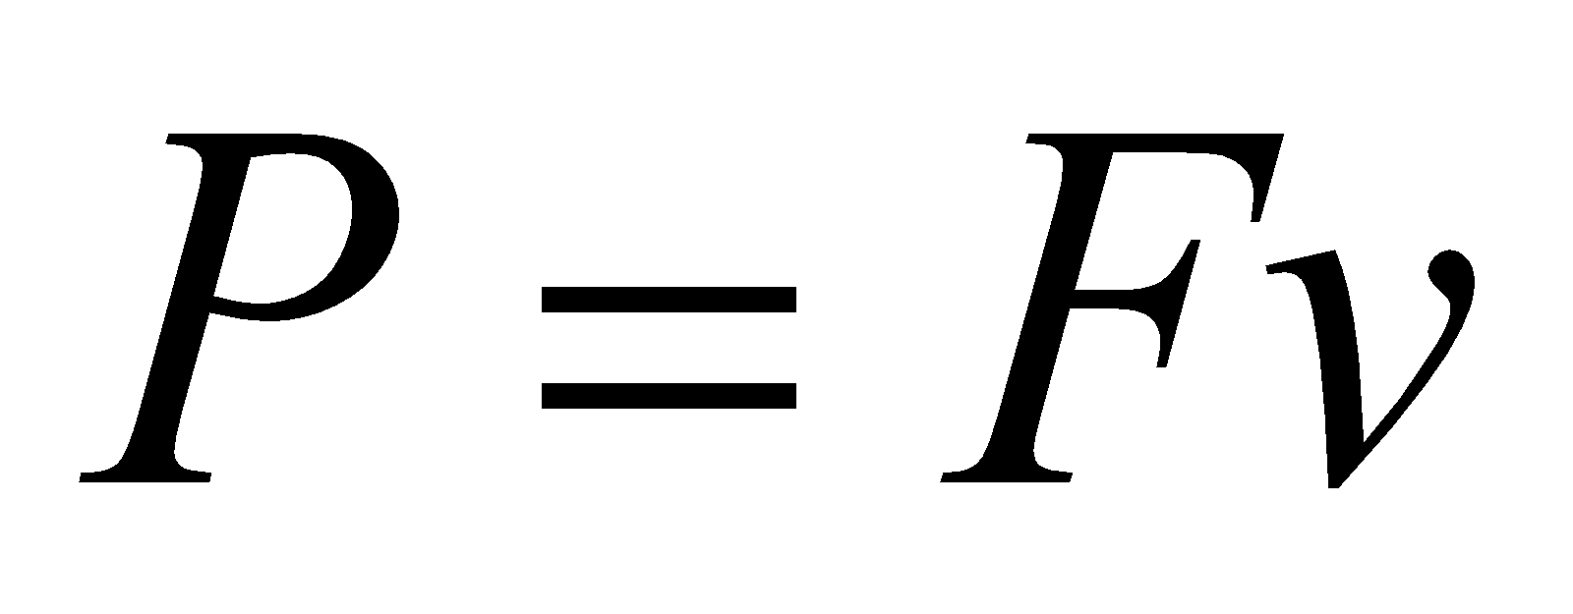
Substitute this into the equation 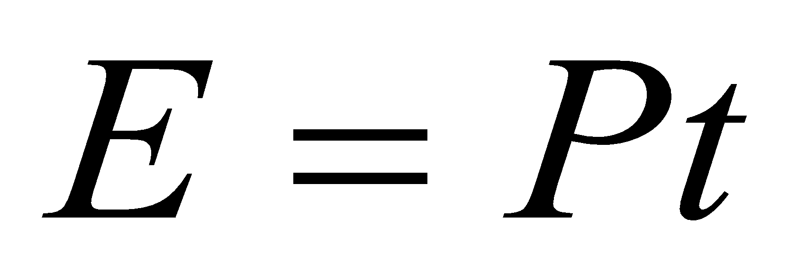
Use 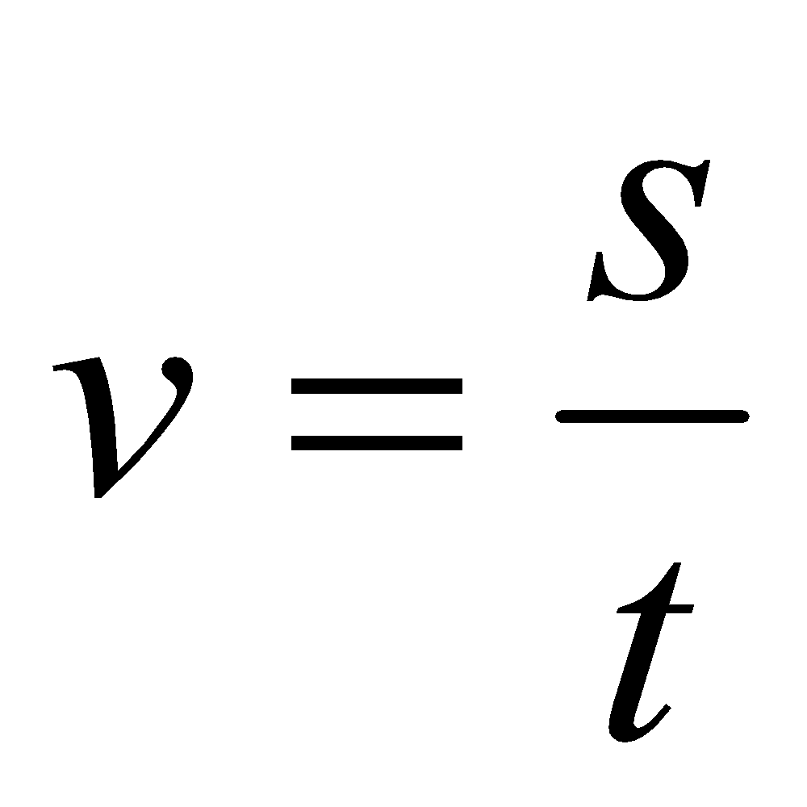 to simplify the equation

Substitute 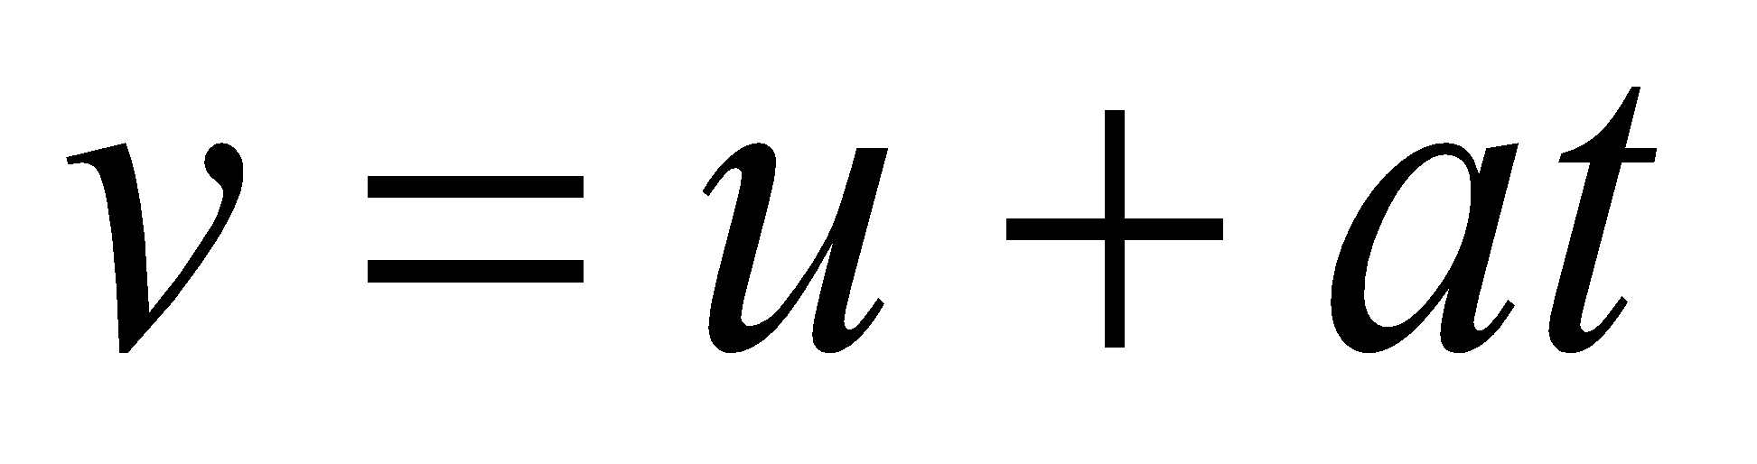 into the equation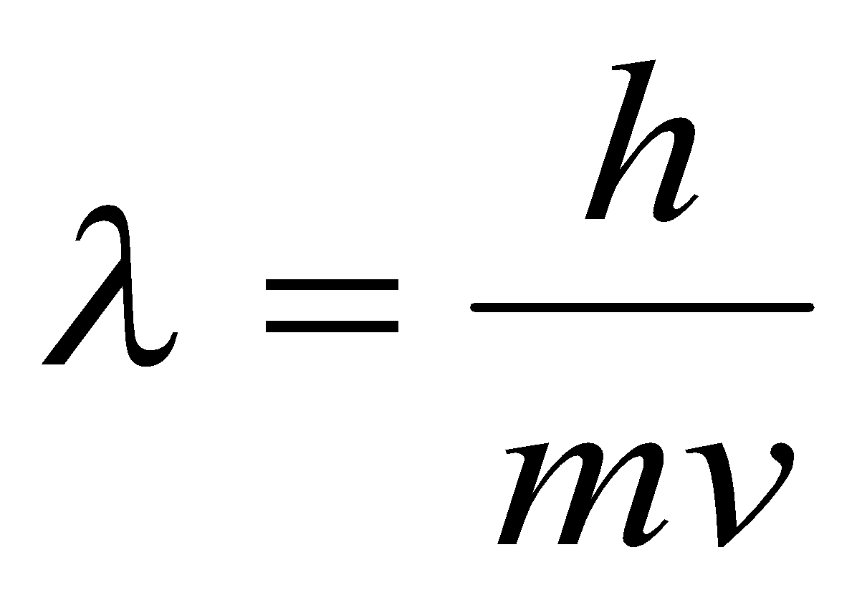
Multiply out the brackets
Substitute this into the equation 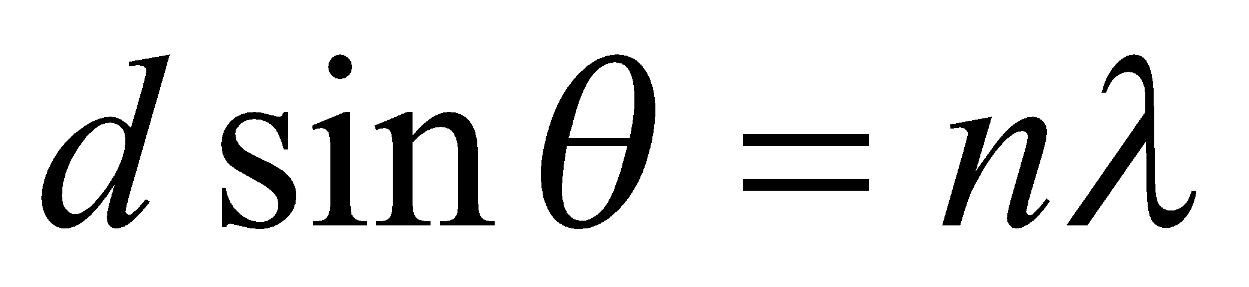
Rearrange the equation to find the angle to the 3rd maxima

Substitute 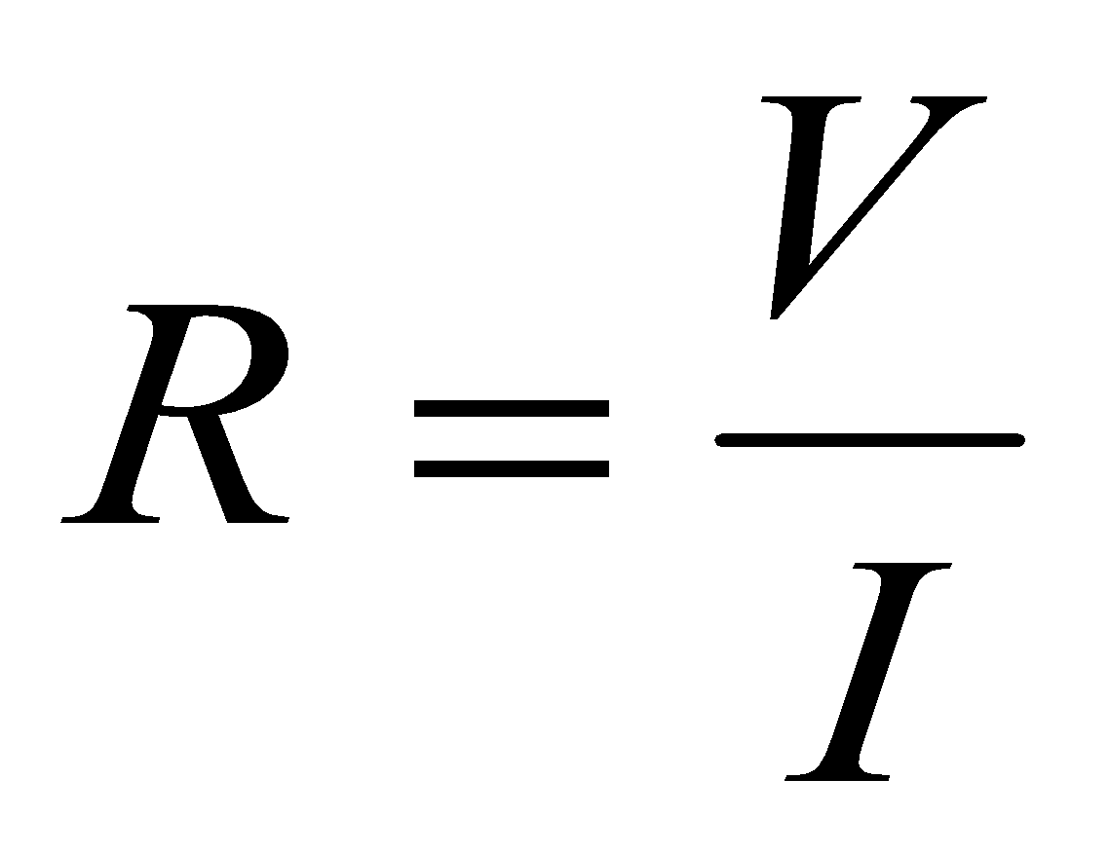 into the equation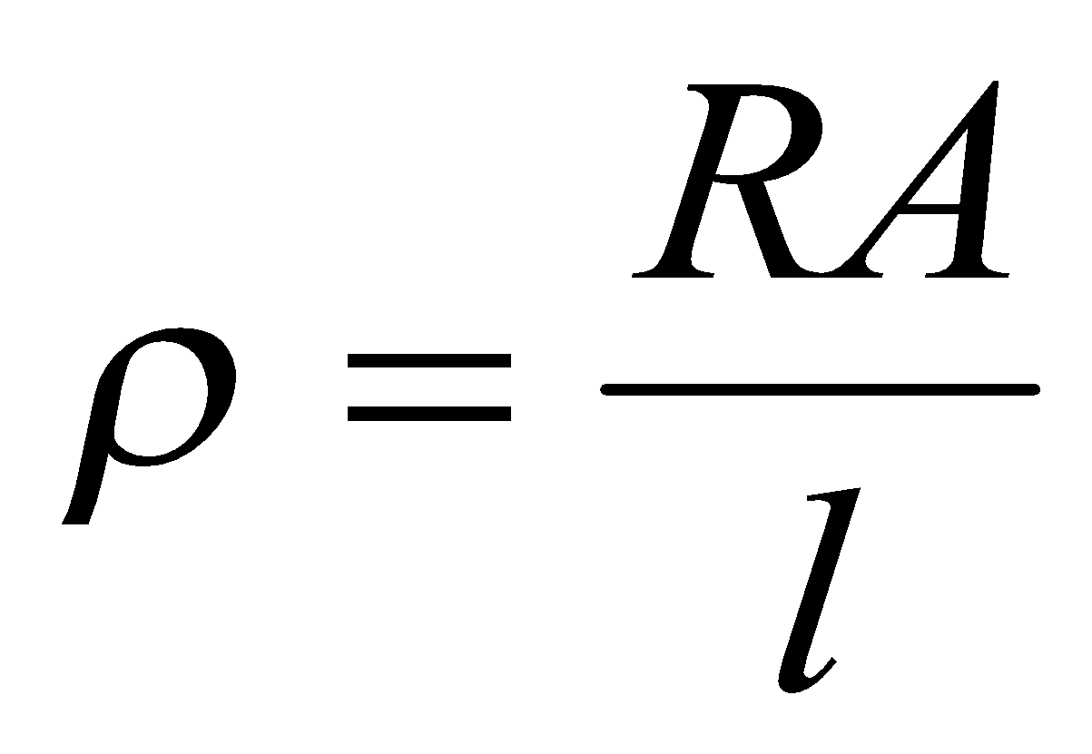
Substitute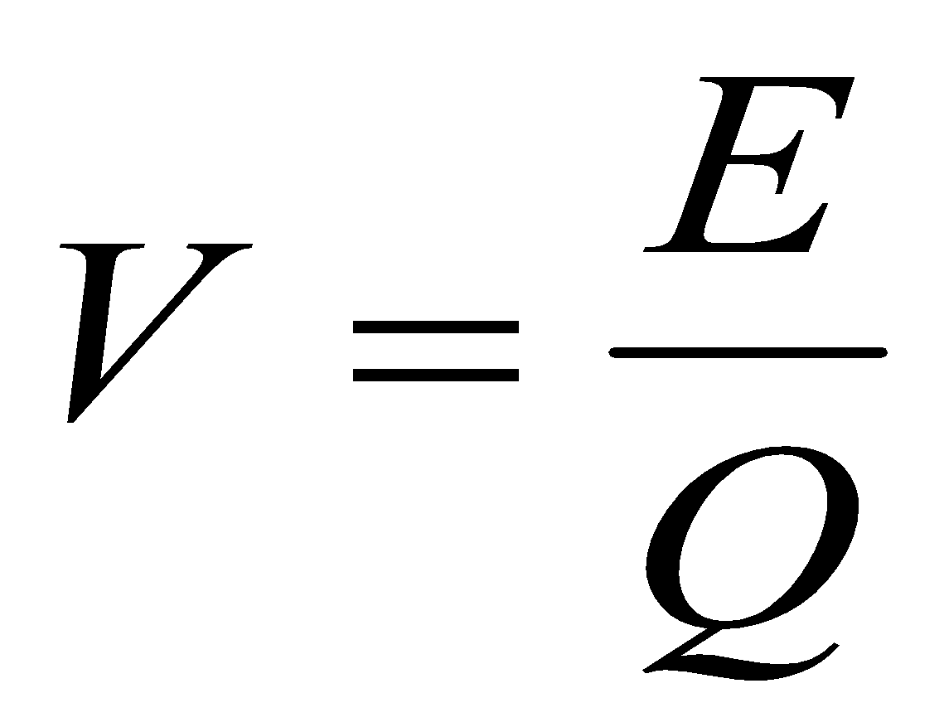into the equation
Substitute into the equation
Use 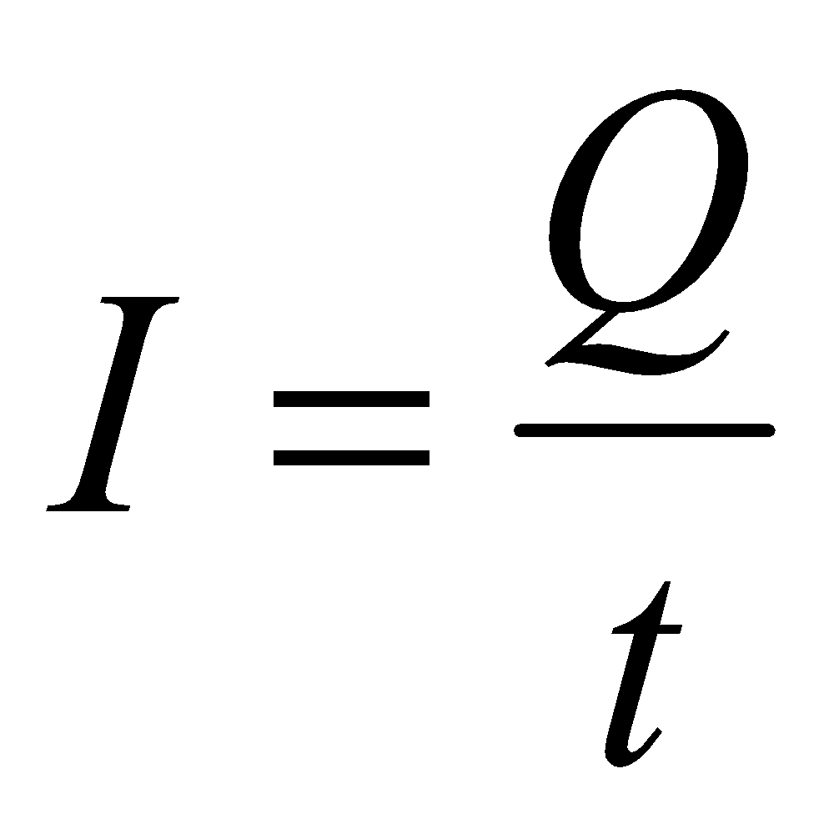 to remove t from the equation
Simplify this

Units

Write down the standard (SI) units for the following quantities.

Energy
Wavelength
Frequency
Power
Moment
Velocity
Acceleration
Mass
Weight
Force
Work Done
Density
Tensile Strength
Tensile Stress
Extension
Young’s modulus
Refractive Index
Momentum
Impulse

