BCCS
Chemistry
A Level
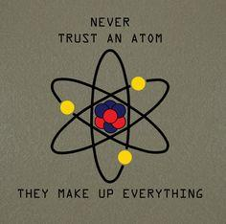

Welcome to A Level Chemistry
The AQA Chemistry GCE course has been designed to ensure that the subject content is relevant to real world experiences and is interesting to teach and learn. The Chemistry specifications are a stepping stone to future study, and have been developed through consultation with top universities, ensuring that students develop the skills that they want to see. We hope that this course will inspire students, nurture a passion for Chemistry and lay the groundwork for further study in Sciences.
Course Content
The course is divided up into 3 areas of study:
- Physical Chemistry
- the study of macroscopic, atomic, subatomic, and particulate phenomena in chemical systems in terms of laws and concepts of physics
- topics include bonding, kinetics, equilibria, energetics, redox, acids and bases and amount of substance
- Inorganic Chemistry
- the study of the synthesis and behavior of inorganic and organometallic compounds
- topics include periodicity, group 2, group 7 and transition metal chemistry
- Organic Chemistry
- study of the structure, properties, and reactions of organic compounds and organic materials, i.e., matter in its various forms that contain carbon atoms
- topics include alkanes, alkenes, isomerism, carbonyl groups, amines, amino acids and organic synthesis and analysis
For more information on the content of the Chemistry AQA course, download the specification from:
http://filestore.aqa.org.uk/resources/chemistry/specifications/AQA-7404-7405-SP-2015.PDF

Textbooks and Resources
When you join us you will be given access to an online textbook and learning resource via Kerboodle. You will also be given access to a wealth of resources created by your teachers on the schools VLE. We also recommend the following textbooks/resources to support learning outside of the classroom, but these are not essential.
- Calculations in AS/A Level Chemistry by Jim Clark
- New A-Level Chemistry for 2018: AQA Year 1 & 2 Complete Revision & Practice from CGP
- AQA Chemistry A Level Student Book by Ted Lister and Janet Renshaw (this is the one students will have access to online via Kerboodle)
If you completed a Combined Science qualification at GCSE we also recommend that you get this textbook and complete all the activities in it to help bridge the gap between GCSE and A-level effectively.
- New Head Start to A-level Chemistry by CGP
If you are not studying A-level Maths we recommend this textbook to support you with some of the mathematical requirements of A-level Chemistry.
- A-Level Chemistry: Essential Maths Skills by CGP
A Level Assessments
To complete the full A-level students must complete three assessments at the end of Y13 which test students on the content covered in both Y12 and Y13.
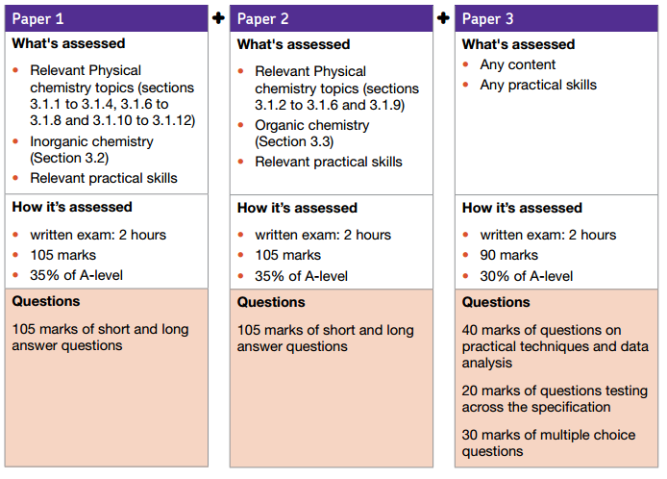

Required Practicals
Coursework/ISAs are no more, but this doesn’t mean that Chemistry will no longer be a practical subject. AQA has issued a list of 12 Required Practicals that you must complete throughout your course, 6 for Y12 and 6 for Y13.
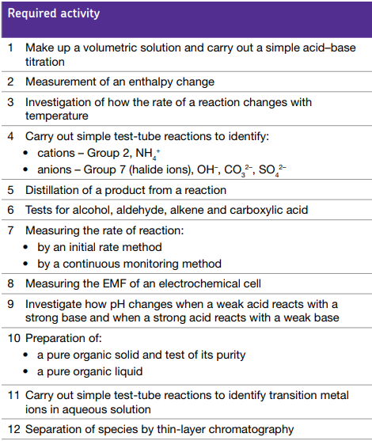

Over to you…..
Chemistry stinks – olfactory indicators experiment

Chemicals that change colour with pH are frequently used as indicators for acid base titrations; however it is also possible to use chemicals that change odour with pH – termed ‘olfactory indicators’. The aim of this experiment is to determine the concentration of an unknown base using garlic powder as an olfactory indicator, and to analyse the accuracy and precision of the results.
Apparatus | Chemicals
Eye protection  Beaker (500cm³), 2  Parafilm or watch glass  Burette (25 cm³)  Pipette (10cm³)  Small funnel  Conical flasks (50cm³ or 100cm³), 3 | Hydrochloric acid solution, HCl(aq) (0.1 M) (IRRITANT) 250cm³  Sodium hydroxide solution, NaOH(aq) (Unknown Concentration, approx. 0.1M) (IRRITANT) 100cm³  Garlic powder (May cause allergic response and skin/eye irritation), approx. 0.4g

What safety precautions do you need to take based on the above chemical information? Do you feel safe and confident conducting the titration experiment?

Procedure
1. Using a small funnel, pour a few cubic centimetres hydrochloric acid, HCl (aq) (0.1 mol dm⁻³) into the burette, with the tap open and a beaker under the open tap. Once the tip of the burette is full of solution, close the tap and add more solution up to the zero mark. (Do not re-use the acid in the beaker – this should be rinsed down the sink with plenty of water.)
2. Use a pipette with pipette filler to transfer 10 cm³ of the unknown concentration garlic infused sodium hydroxide solution to the conical flask.
3. Add the hydrochloric acid to the garlic infused sodium hydroxide solution in small volumes, swirling gently after each addition. A sudden change in intensity to the smell is detectable at the end-point of the titration.
4. Repeat until concordant results are obtained
NB: The smell is detectable in basic conditions but at the end point there is a sudden change of intensity whereby the smell seems to get richer and can easily be detected by wafting the odour towards oneself.

Volume of acid added:

Discussion: How would using an olfactory indicator compare with using a colour-based indicator? How would you rate the accuracy of this method?

Preparation Tasks

The fundamentals in A-level Chemistry are so important to doing well in this subject. Basics like writing formulae, naming compounds and writing equations are essential.
Keep your skills sharp over the holidays by completing the exercises on the following pages. If you need some help with how to complete these exercises you can refer to these websites:
http://www.bbc.co.uk/education/guides/zysk7ty/revision/1
http://www.bbc.co.uk/schools/gcsebitesize/science/add_aqa_pre_2011/chemcalc/chemcalc_higherrev2.shtml

Good luck with the exam results - we look forward to seeing you in our labs in September.

Mrs Jackson
Mr Dunton
Dr Harris
Mr Robotham

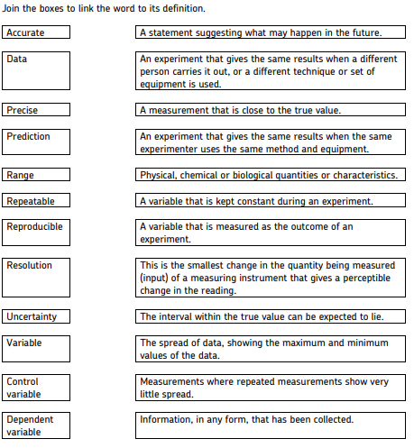
1. Important vocabulary for practical work
There are many words used in practical work. You will have come across most of these words in your GCSE studies. It is important you are using the right definition for each word.

2. The Periodic table
The periodic table of elements is shown on the next page of this booklet. The A-level course will build on what you’ve learned in your GCSE studies.
On the periodic table on the following page:
- Draw a line showing the metals and non-metals.
- Colour the transition metals blue.
- Colour the halogens yellow.
- Colour the alkali metals red.
- Colour the noble gases green.
- Draw a blue arrow showing the direction of periods.
- Draw a red arrow showing the direction of groups.
- Draw a blue ring around the symbols for all gases.
- Draw a red ring around the symbols for all liquids.

Use the periodic table to find the following:
1. The atomic number of: osmium, sodium, lead, chlorine.

2. The relative atomic mass of: helium, barium, europium, oxygen.

3. The number of protons in: mercury, iodine, calcium.

3. Atomic number and Relative atomic mass (Ar)
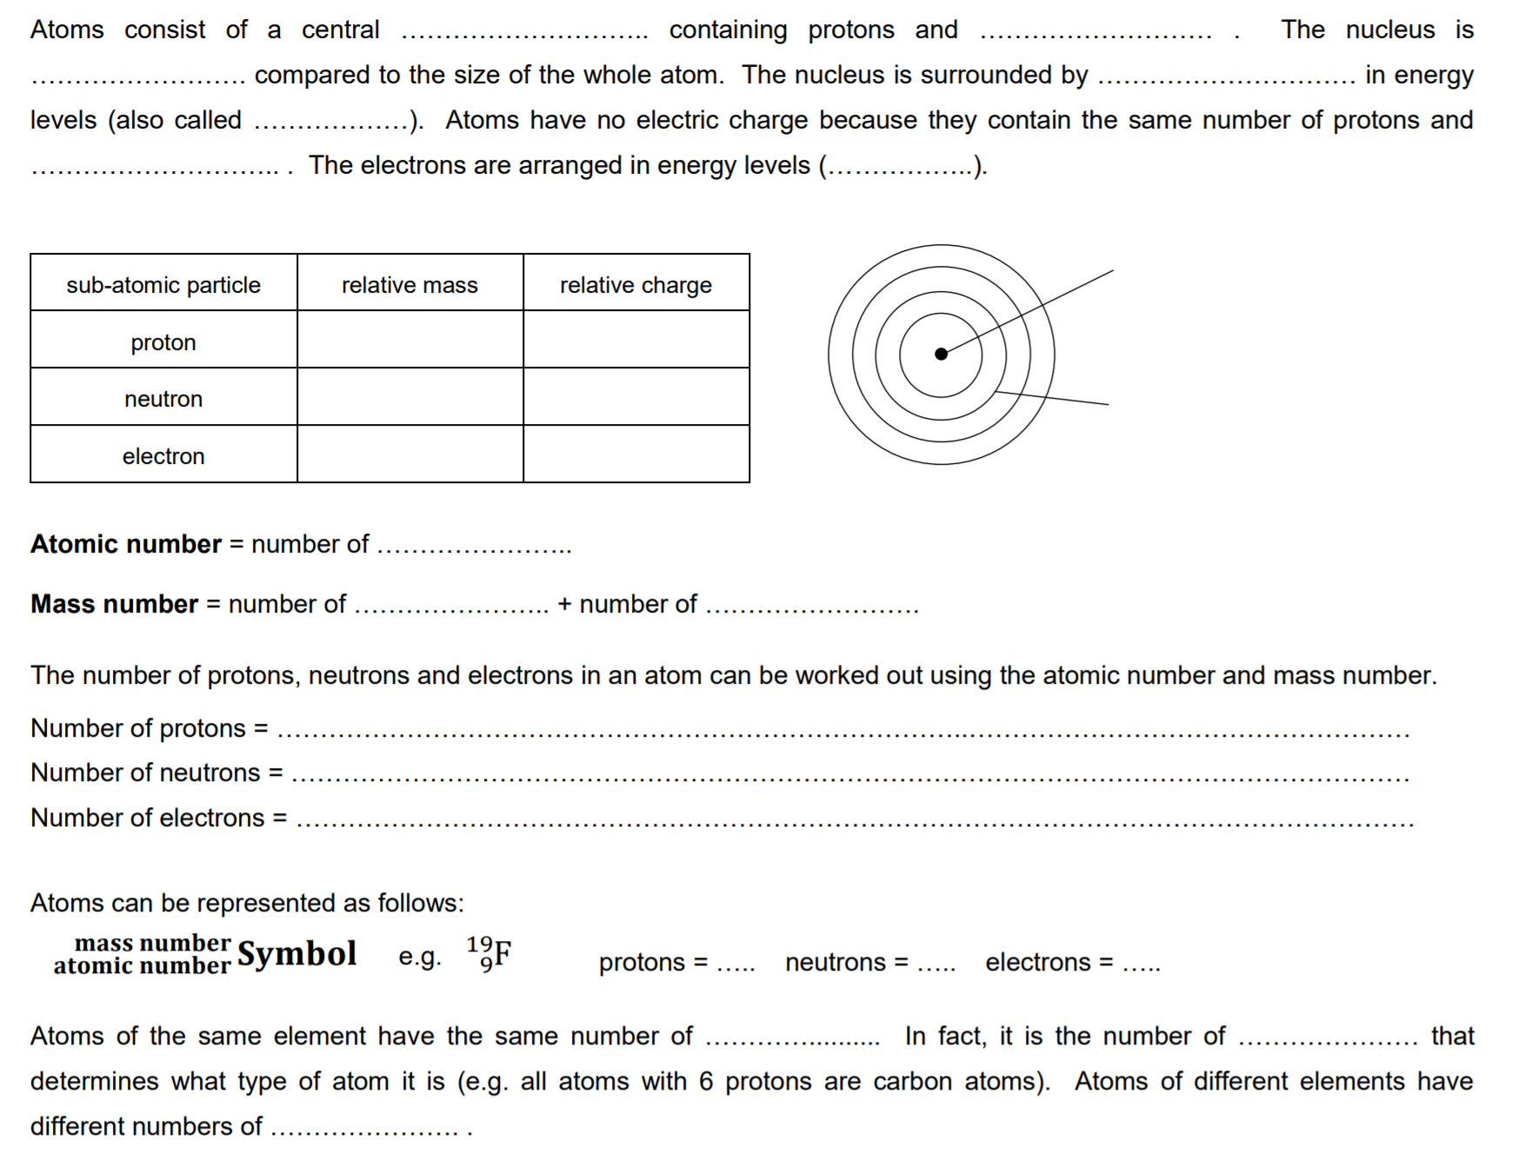
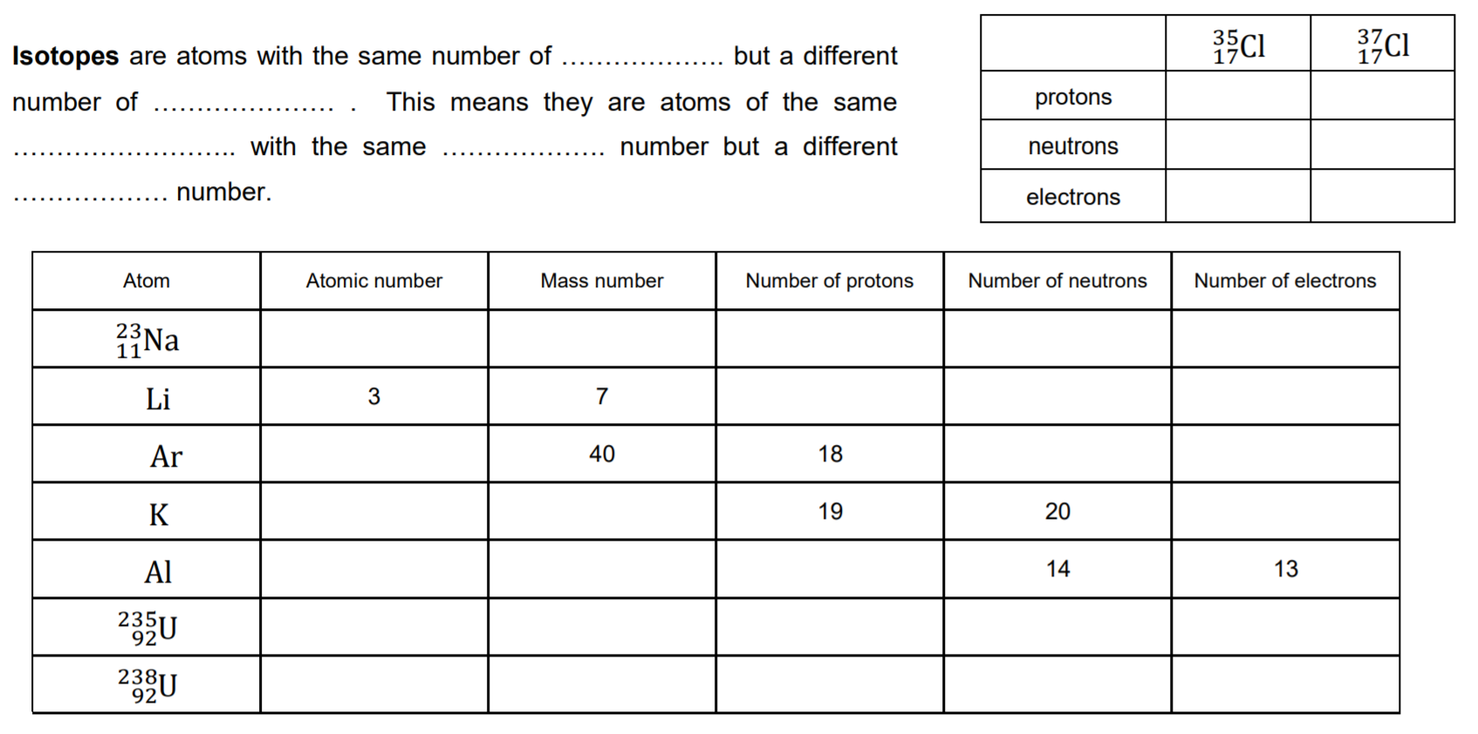
4. Relative formula mass (Mr)
Carbon dioxide, CO₂ has 1 carbon atom (Ar = 12.0) and two oxygen atoms (Ar = 16.0). The relative formula mass is therefore Mr = (12.0 × 1) + (16.0 × 2) = 44.0
Magnesium hydroxide Mg(OH)₂ has one magnesium ion (Ar = 24.3) and two hydroxide ions, each with one oxygen (Ar = 16.0) and one hydrogen (Ar = 1.0). The relative formula mass is therefore: (24.3 × 1) + (2 × (16.0 + 1.0)) = 58.3
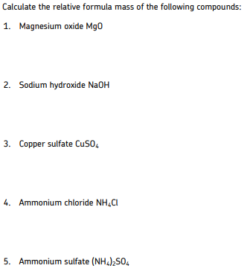

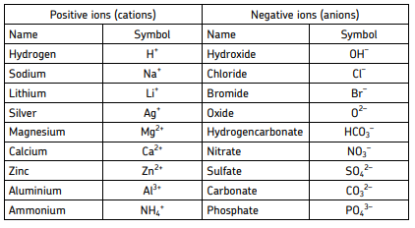
5. Common Ions

Some elements have more than one charge. For example, iron can form ions with a charge of +2 or +3. Compounds containing these are named Iron(II) and Iron(III) respectively.
Other common elements with more than one charge include: Chromium(II) and Chromium(III), Copper(I) and Copper(II) and Lead(II) and Lead(IV).
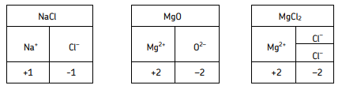
Ionic compounds must have an overall neutral charge. The ratio of cations to anions must mean that there is as many positives as negatives. For example:

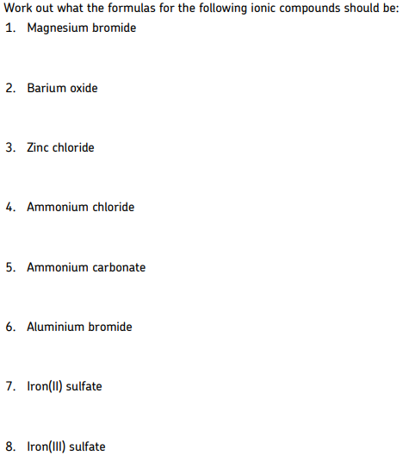

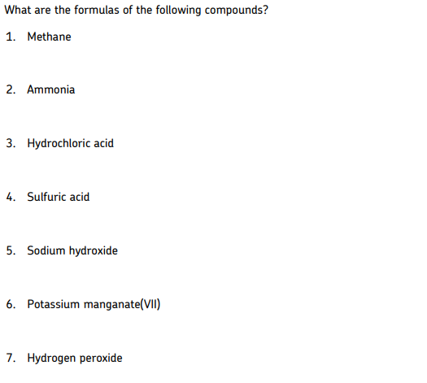
6. Common compounds
There are several common compounds from your GCSE studies that have names that do not help to work out their formulas. For example, water is H₂O.

7.Balancing equations
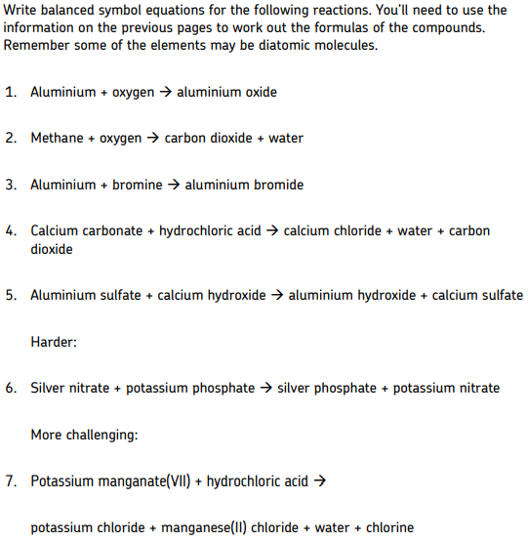
Chemical reactions never create or destroy atoms. They are only rearranged or joined in different ways. When hydrogen and oxygen react to make water:
H₂ + O₂ --> H₂O
There are two hydrogen atoms on both sides of this equation, but two oxygen atoms on the left and only one on the right. This is not balanced. This can be balanced by writing:
2H₂ + O₂ --> 2H₂O
To balance the equation, a number must be added in front of the compound or element in the equation. This is a coefficient. Coefficients show how many atoms or molecules there are.

8. Moles
A mole is the amount of a substance that contains 6.02 × 10²³ particles.
The mass of 1 mole of any substance is the relative formula mass (Mr) in grams.
Examples:
One mole of carbon contains 6.02 × 10²³ particles and has a mass of 12.0 g
Two moles of copper contains 12.04 × 10²³ particles, and has a mass of 127 g
1 mole of water contains 6.02 × 10²³ particles and has a mass of 18 g
The amount in moles of a substance can be found by using the formula:
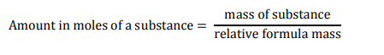
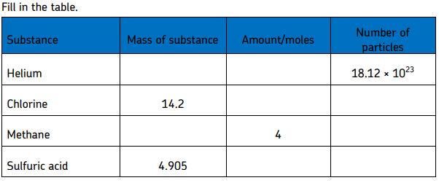

9. Empirical formula
If you measure the mass of each reactant used in a reaction, you can work out the ratio of atoms of each reactant in the product. This is known as the empirical formula. This may give you the actual chemical formula, as the actual formula may be a multiple of this. For example, hydrogen peroxide is H₂O₂ but would have the empirical formula HO.
Use the following to find an empirical formula:
1. Write down reacting masses
2. Find the amount in moles of each element
3. Find the ratio of moles of each element
Example:
A compound contains 2.232 g of ion, 1.284 g of sulfur and 1.920 g of oxygen. What is the empirical formula?
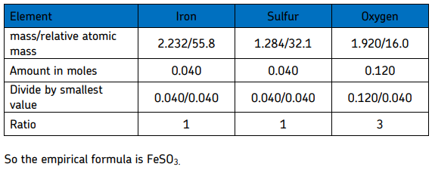
If the question gives the percentage of each element instead of the mass, replace mass with the percentage of an element present and follow the same process.
