A Level History
Preparation Pack
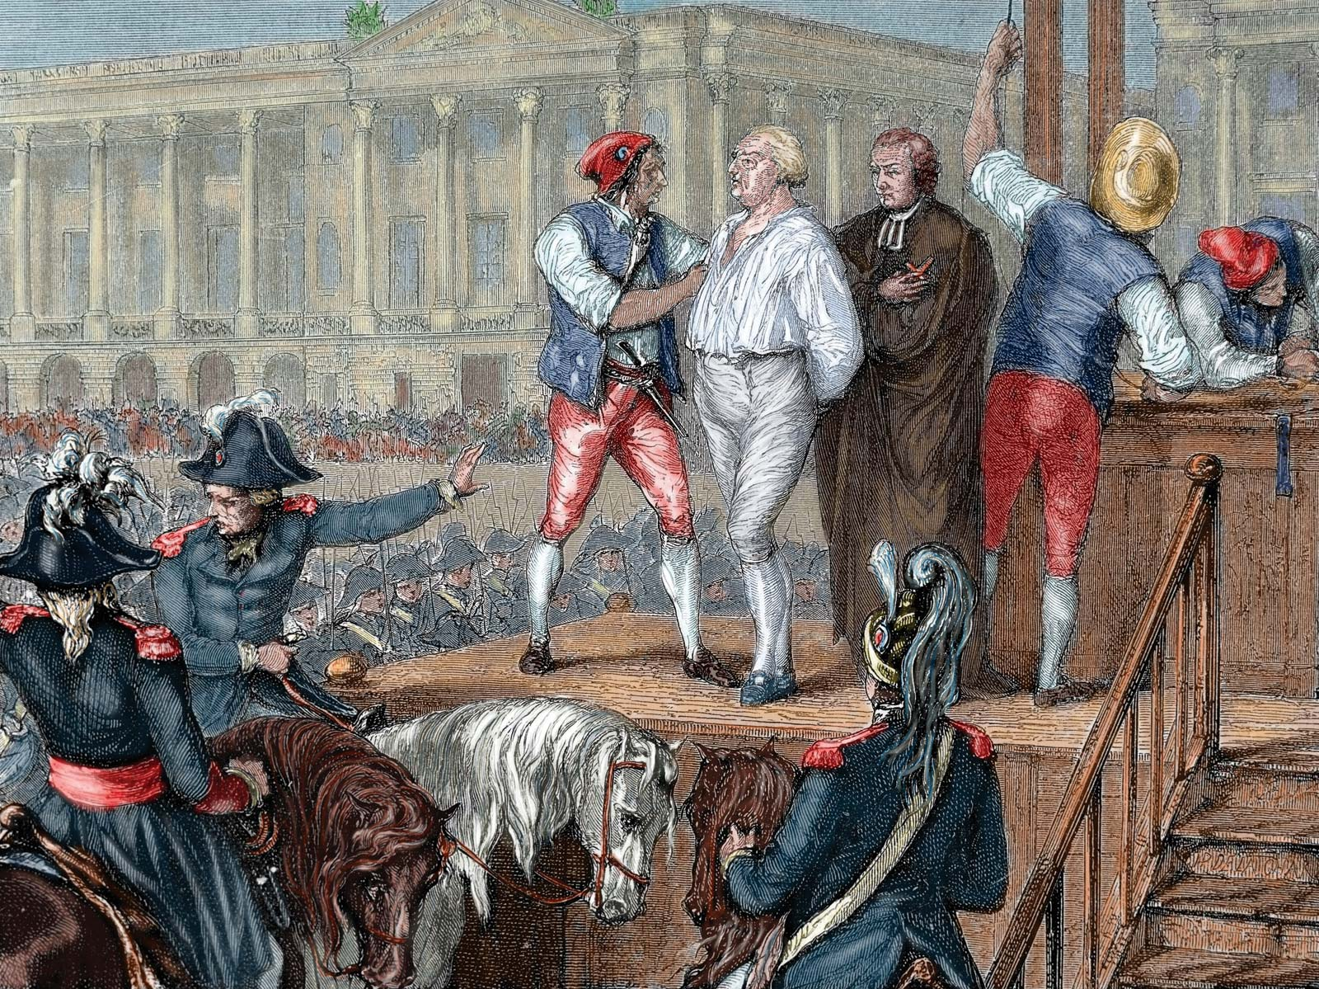

Welcome, year 11! This is your Transition Pack for A level History, which you’ve chosen to take at A level this September. The pack is designed to give you a flavour of what A level History is all about. Don’t feel you need to complete it all in one go! You can complete the tasks in this booklet in the spaces provided.

A Level course outline
1C: The Tudors: England: 1485-1603 | 2H: France in Revolution, 1774-1815 | NEA: Russia: From Autocracy to Dictatorship, 1855-1953

Task One: Chronology

During your A Level studies you will be exploring new time periods, topics and themes in both breadth and depth. Understanding the key chronology of your units will be central to your ability to both analyse sources in their context and engage critically and meaningfully with essay questions.
Step 1: Identify which three examination units you will be completing as part of your A Level studies.
Step 2: Create a timeline on A3 paper which spans the entire time period you will be studying for each of your three units.
Step 3: On your timeline, plot on the key events with full dates and titles.
Step 4: For each event, can you write a brief description of what happened and the consequences of it?
Step 5: In a separate colour, draw and annotate arrows explaining the connections between the events in your timeline – how are key events/changes connected?
Step 6: Counterfactual analysis is a key component of A Level study. For 5 of the events on your timeline, can you explain how history would have been different if this event had not occurred? Can you predict how your timeline might have looked different? What does this tell you about the importance of this event within this unit of work?
Challenge: Can you now begin to explain the strengths and limitations of timelines? How far, and in what ways, will they be useful to you in studying the past?

Task Two: Causation and Consequence
A majority of the essays you write throughout Year 12 and Year 13 will address the conceptual focuses of causation and consequences – why do events happen, and what are the implications of them?
Step 1: From your timeline for each of your examination units, identify 5 key events (if in doubt, double check with your History teacher for Year 12 to see if the events you have chosen are suitable!).
Step 2: Create a mind map, with the event in the middle, divided into two sections – causes and consequences.
Step 3: On the left hand-side, identify between 5-10 causes as to why this event happened. For each event use the “shades of likelihood” scale to explain how far, and in what ways, this cause led to the event occurring:
1 2 3 4
Partially Noticeably Dramatically Certainly
Step 4: For your causes, now categorise your factors into the following themes: political; social; economic; long-term cause; and short-term cause.
Step 5: From your causation map, can you now identify what you think is the most important cause behind this event, and justify your decision?
Step 6: On the right hand-side, identify between 5-10 consequences that occurred as a result of this event.
Step 7: For your consequences, now categorise them into the following themes: political; social; economic; long-term consequence; and short-term consequence. Can you explain the links between your consequences?
Step 8: Can you identify what you think is the most important consequence of this event, and justify your decision?
Task Three: Significance

One of the central recurring themes in A Level History is the role and significance of individuals in shaping events. Why is it that some individuals are more significant than others? In what ways, if at all, can the contributions of some individuals to the past be unprecedented? In what ways are some events in the past inevitable, unaffected by human agency?

Step 1: From your timeline, identify 5 key individuals from each of your examination units (if in doubt, double check with your History teacher for Year 12 to see if the people you have chosen are suitable!).

Step 2: For each of your individuals, complete the grid below, explaining the ways that they are significant:
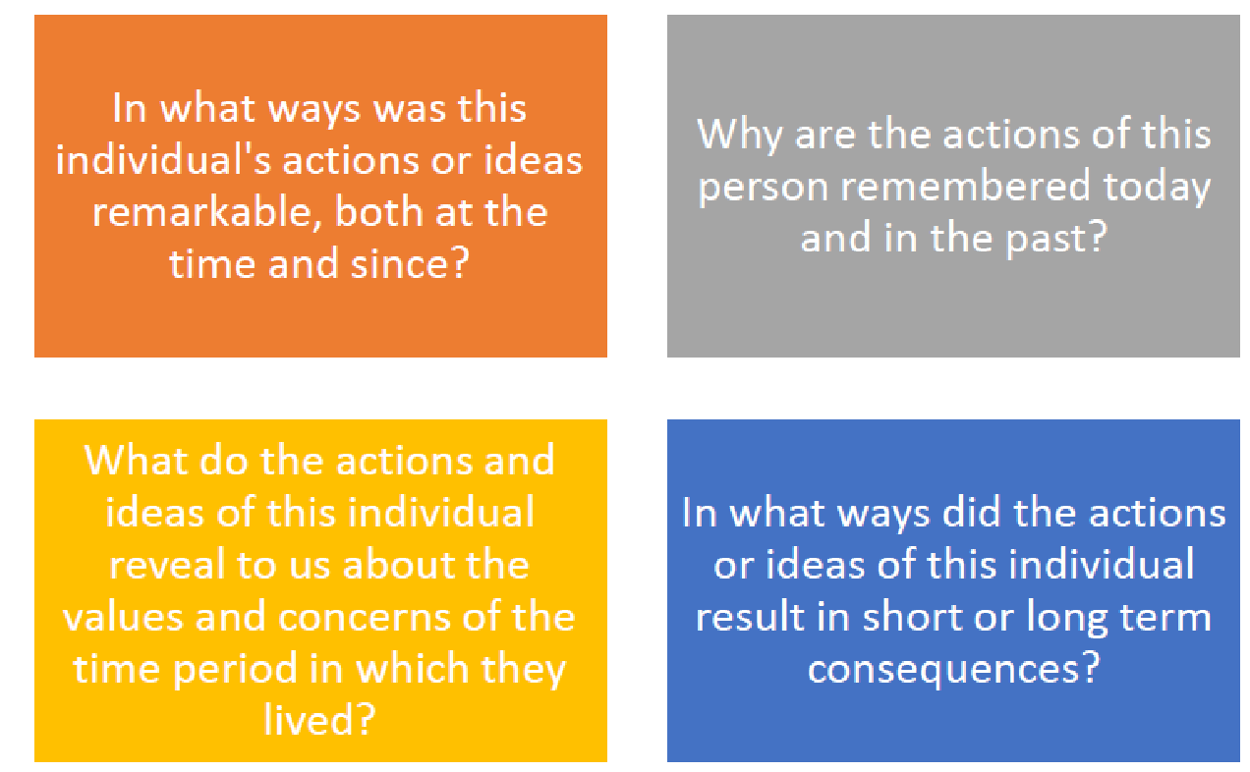
Step 3: Based upon your grids, which of your individuals do you think was most significant and why? If you had to rank them into an order of significance, what would your criteria be for what makes an individual significant in the past?
Task Four: Extend
To be in the best position to succeed at A Level it is essential to develop a sense of period. In other words, to understand what the key issues of the time were and what the era was like. In order to do this, you can extend your learning by completing the following:

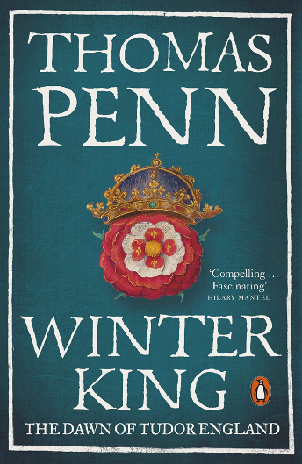
1C: The Tudors, England, 1485-1603

Step 1: The short video below, explains how Henry VII became king and began the Tudor dynasty (it also explains how Game of Thrones was based on the Wars of the Roses!).
https://www.youtube.com/watch?v=VjO55pKuBo4

Step 2: Watch the hour long BBC documentary about Henry VII’s reign. This will give you a really good introduction to the beginning of the Tudor dynasty. The documentary is made the historian, Thomas Penn, who wrote the Winter King.
https://www.youtube.com/watch?v=-5FsriGn300

2H: France in Revolution, 1774-1815

Step 1: Watch and note-take the following online lessons on the French Revolution:
Part 1 - https://youtu.be/5pXxoyk5wOo
Part 2 - https://youtu.be/BDWqwcTtZa0
Part 3 - https://youtu.be/0t4MF9ZoppM

Step 2: Watch the two epic films which tell the story of the turbulent years 1789-1794:
Part 1 - The Years of Light: https://www.bitchute.com/video/ZT3k5501gS5i/
Part 2 - The Years of Terror: https://www.bitchute.com/video/OFNuIhzmbbzy/

