Graphic Art:

- Listen to the Reith Lectures with Grayson Perry.
- Read 'Ways of Seeing' by John Berger

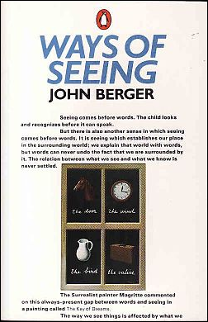

- Read 'Art and Fear' by David Bayles and Ted Orland

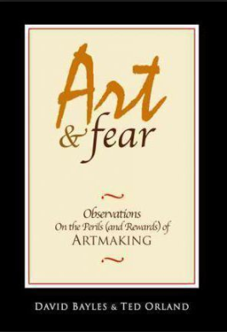

- Create a Pinterest account and start collecting images relating to distortion. Make sure that these are relevant to either Fine Art or Graphics - depending upon which one you are taking. See below for inspiration:

https://www.pinterest.co.uk/artevie/distortion/?lp=true

